📘 PROJECT REPORT
- Digital Addiction Analysis Using Data Analytics
1️⃣ Introduction
In today’s digital era, excessive usage of smartphones, social media, and online platforms has led to increasing concerns about digital addiction. Prolonged screen time can negatively impact sleep patterns, mental health, and overall lifestyle.
This project aims to analyze user digital behavior and identify patterns related to screen time and its impact on sleep using Python, SQL, and Power BI.
2️⃣ Problem Statement
The increasing use of digital devices has raised concerns regarding:
- Excessive daily screen time
- Reduced sleep duration
- High dependency on digital platforms among young users
The challenge is to analyze digital usage data and extract meaningful insights that help understand the relationship between screen time, sleep hours, and user demographics.
3️⃣ Objectives of the Project
- To analyze daily screen time behavior of users
- To study the impact of screen time on sleep duration
- To identify age groups most affected by digital addiction
- To build an interactive dashboard for clear visualization of insights
4️⃣ Dataset Description
The dataset contains information related to digital usage behavior of users, including:
- user_id – Unique identifier for users
- age – Age of the user
- gender – Gender of the user
- screen_time_hours – Daily screen usage hours
- sleep_hours – Daily sleep duration
- Other behavioral attributes related to digital usage
The dataset was stored in CSV format and used across Python, SQL, and Power BI.

5️⃣ Tools & Technologies Used
Tool | Purpose
Python (Pandas) | Data loading & basic exploration
SQL (MySQL Workbench) | Data querying & analysis
Power BI | Data visualization & dashboard creation

6️⃣ Data Preprocessing (Python)
Python was used for initial data exploration and validation.
Key Steps Performed:
- Loaded the dataset using Pandas
- Checked data structure and data types
- Identified missing (null) values
Sample Python Code:
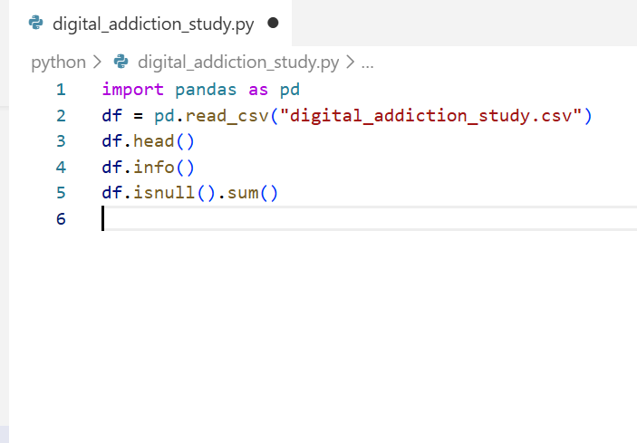
This ensured that the dataset was clean and ready for further analysis.

7️⃣ SQL Analysis
The cleaned dataset was imported into MySQL Workbench, and the following analytical questions were solved using SQL:
✔️ SQL Questions Covered:
- Total number of users in the dataset
- Average daily screen time of users
- Number of high screen time users
- Find the average gaming hours per day for each gender.
These queries helped in extracting structured insights before visualization.
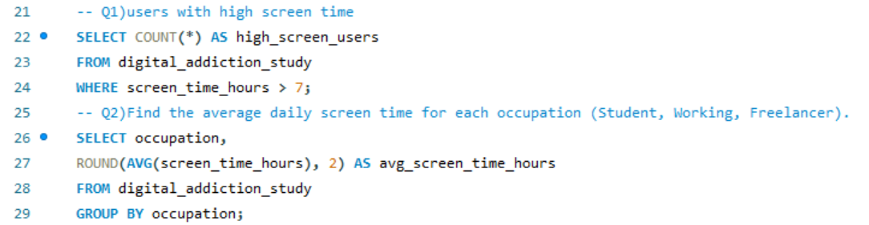
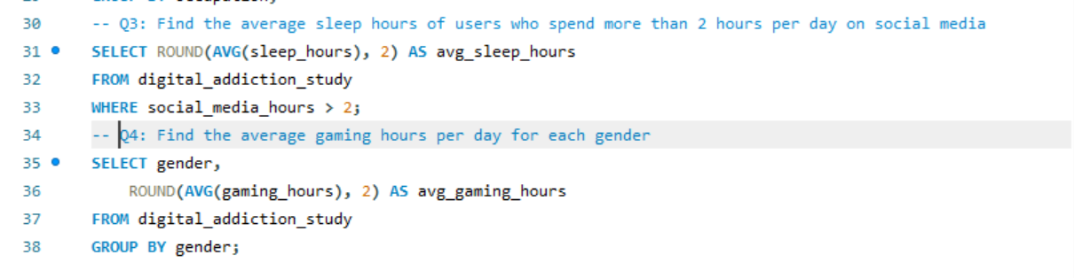
8️⃣ Power BI Dashboard Analysis
An interactive Digital Addiction Analysis Dashboard was created in Power BI to visualize key insights.
📊 Dashboard Components:
🔹 KPI Cards
- Total Users Analyzed
- Average Daily Screen Time
- High Screen Time Users
🔹 Visualizations
- Scatter Plot: Daily Screen Time vs Sleep Hours
- Donut Chart: Users belonging to different age groups
- Clustered Column Chart: Average sleep hours by screen time
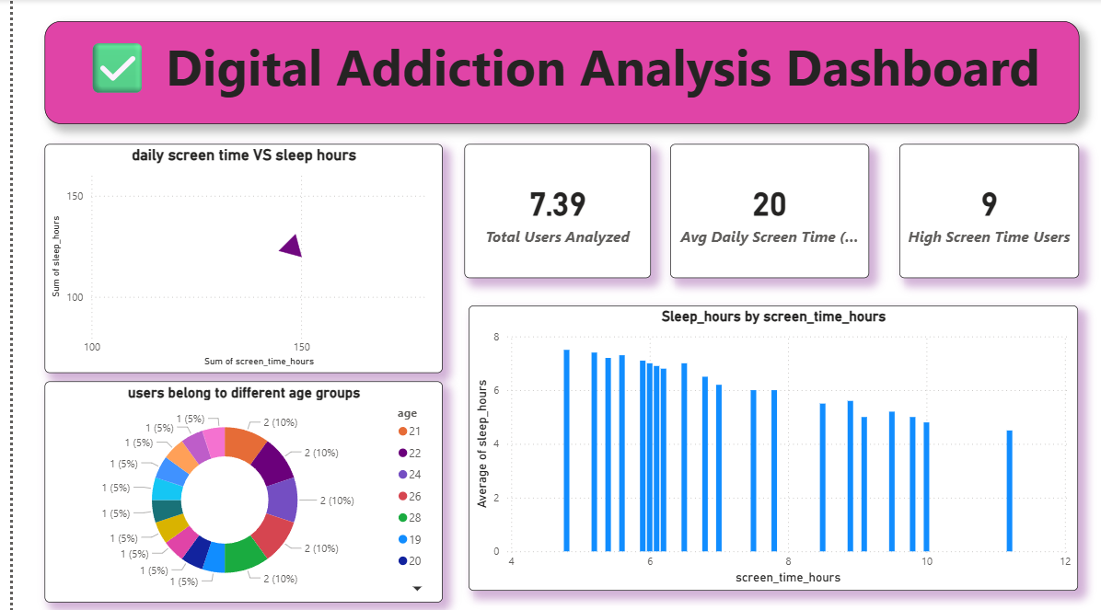
9️⃣ Key Insights
- Users with higher screen time tend to have lower sleep duration
- Young age groups show higher engagement with digital devices
- Excessive digital usage indicates potential digital addiction patterns
- Visual trends clearly show the negative impact of screen time on sleep
🔟 Conclusion
This project successfully demonstrates how data analytics can be used to study digital addiction trends.
By combining Python, SQL, and Power BI, meaningful insights were extracted and
presented through an interactive dashboard.
The findings highlight the importance of balanced digital usage to maintain healthy sleep and lifestyle patterns.
🔮 Future Scope
- Include mental health indicators such as stress and mood levels
- Perform predictive analysis on digital addiction risk
- Extend analysis using real-time or larger datasets

1️⃣1️⃣ Final Outcome
The project provides a clear, data-driven understanding of digital addiction, making it useful for academic analysis as well as real-world decision-making.

